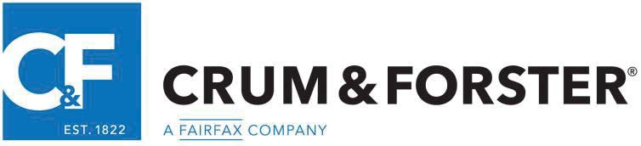

## Crum & Forster Specialty Insurance Company

305 Madison Avenue

Morristown, NJ 07960

**COMMON POLICY DECLARATIONS**

### POLICY NUMBER: RENEWAL OF:

**NAMED INSURED: MAILING ADDRESS:**

**PRODUCER:** UNIVERSAL INSURANCE PROGRAMS, LLC

**MAILING ADDRESS:** 1220 EAST OSBORN ROAD, PHOENIX, AZ 85014

**POLICY PERIOD:** FROM TO AT 12:01 AM STANDARD TIME AT YOUR MAILING ADDRESS SHOWN ABOVE.

**BUSINESS DESCRIPTION:**

**IN RETURN FOR THE PAYMENT OF THE PREMIUM, AND SUBJECT TO ALL TERMS OF THIS POLICY, WE AGREE WITH YOU TO PROVIDE THE INSURANCE AS STATED IN THIS POLICY.**

|  |
| --- |
| **THIS POLICY CONSISTS OF THE COVERAGE PARTS FOR WHICH A PREMIUM IS INDICATED.** |
| **Professional Liability** |
| **Employment Practices Liability** |
| **Commercial Property** |
| **Commercial General Liability** |
| **Employee Theft** |
| **Cyber Liability** |
| **TOTAL PREMIUM (including additional premium)** |
| **Broker Fee** |
| **State Tax** |
| **Stamping Fee** |
| **TOTAL ANNUAL COST** |

**OTHER PROVISIONS:**

**Inflation Guard 2%**

**FORMS AND ENDORSEMENTS APPLICABLE TO ALL COVERAGE PARTS:**

**See Forms Schedule**

NOTE: IF NO ENTRY APPEARS ON THE ABOVE ENDORSEMENTS, INFORMATION REQUIRED TO COMPLETE THE FORM WILL BE SHOWN ON THE SUPPLEMENTAL FORM DECLARATION IMMEDIATELY PRECEDING THE APPLICABLE ENDORSEMENT

THESE DECLARATIONS, IF APPLICABLE, TOGETHER WITH THE COMMON POLICY CONDITIONS, COVERAGE FORM(S) AND ENDORSEMENTS, AND SUPPLEMENTAL FORM DECLARATION(S), IF ANY, ISSUED TO FORM A PART THEREOF, COMPLETE THE ABOVE NUMBERED POLICY.

UIP 001 06 20